TAKE A VIRTUAL TOUR IN LONDON
Log onto http://www.projectbritain.com/london/
Today's date: ….......................................................................................................................

Next May 2014

We will arrive at Heathrow Airport and take the TUBE ( or the UNDERGROUND). How much will it cost me to Central London? …........................................................
( resources.woodlands-junior.kent.sch.uk/customs/questions/london/airports.html)

We will visit the capital of England, the biggest city in Great Britain and in Europe, London .There are …........................................ inhabitants. ( http://www.projectbritain.com/london/facts.htm)
In the morning we will see The Parliament and many of the government offices which are located in ( district) .................................................................... and in the afternoon we will see the business and financial heart of London , ( district)…......................................................................................... .

What will we see ?( http://www.projectbritain.com/london/landmarks/index.htm). Write a few lines about them.
 | Name and date of construction | Function ? Number of rooms? ...
When I get close to the gates of Buckingham Palace I will see the footguards. Colour their uniform.
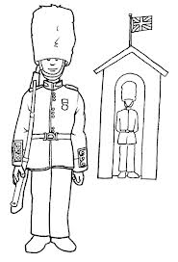
I will/ won't manage to make them smile.

At lunch time we will have a packed lunch composed of …

( http://resources.woodlands-junior.kent.sch.uk/customs/questions/food/meals.htm)
Choose the best park to have your packed lunch in, next to Buckingham : …..........................................................................................

After our picnic we will go down the Mall and arrive at this place . What is its name? Who is standing at the top of the column?
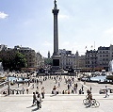

Name:

Just behind this place there is one of the greatest museum in London, famous for its rich collection of European paintings :(http://www.projectbritain.com/london/attractions/museums.html) …........................................................

In the afternoon we will visit one of the most incredible museums, where we will see a life- sized blue whale and a great permanent exhibition of dinosaurs. Its name is ….

Or you will visit a museum located just next to, in South Kensington. Its name is ….

Log onto the website on these museums and say which one you prefer :

Late in the afternoon we will ride on the highest observation wheel in the world.
We will pay …................................................. to see the best landmarks in London.
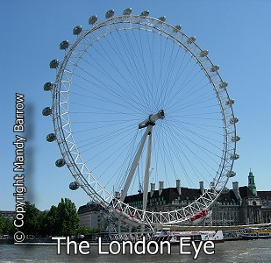

….................................. metres high

I will go shopping in one of the busiest shopping area in London,..............................................
( name) and buy some souvenirs for my parents and my four- year- old sister for only 12 pounds.
My souvenirs:( http://www.projectbritain.com/activities/typicalenglish.htm)

Finally we will take the Ferry Boat at Westminster Bridge and cross river …........................... (name) to 'The City' . We will sail past these places:
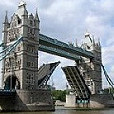

Find in the website eveyrything that is RED:

